Global Industries Report
Global Industries Report is centered on the websites traffic statistics that represent company’s portfolio offers.
The report is sourced using APIs and Google Analytics data and is represented by the following tables:
- GI_API_transformation - r
- GI_Pageviews_dataset – r
- GI_Users_dataset - r
- Index_GI - r
Additional datasets
- Last Refresh Table
- Date Table – for Pageviews table statistics
- Date Table 2 - for Users table statistics

Relationships
Table (column) | Relationship | Table (column) | Status
GI_API_transformation- r (id) | Cardinality:  Many to Many  Cross-filter direction: Both | GI_Pageviews_dataset - r (id) | Active
GI_API_transformation- r (id) | Cardinality:  Many to Many  Cross-filter direction: GI_API filters RLS | GI_Users_dataset – r (id) | Active
GI_Pageviews_dataset - r (Date) | Cardinality:  Many to one  Cross-filter direction: GI_API filters Date Table | Date Table | Active
GI_Users_dataset - r (Date) | Cardinality:  Many to one  Cross-filter direction: GI_API filters Date Table 2 | Date Table 2 | Active

Data model
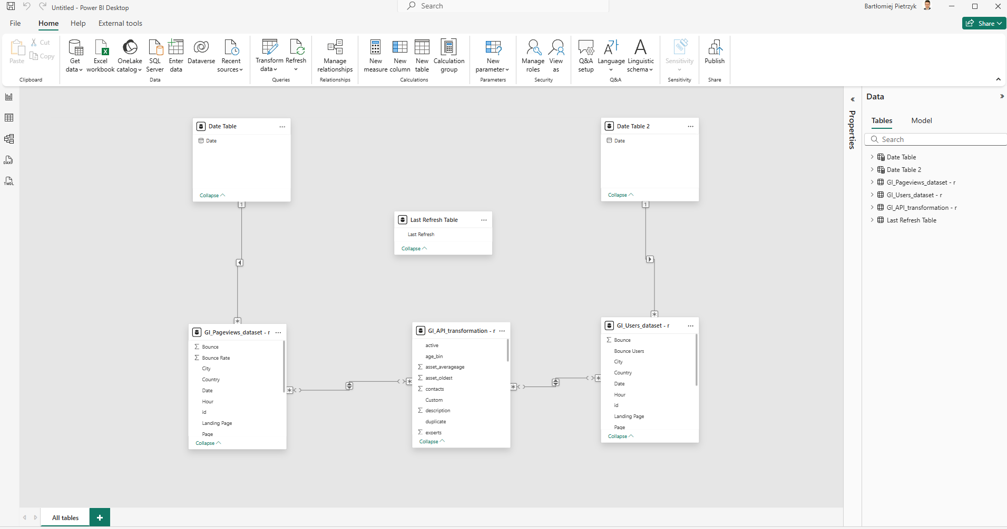

Dataflow architecture
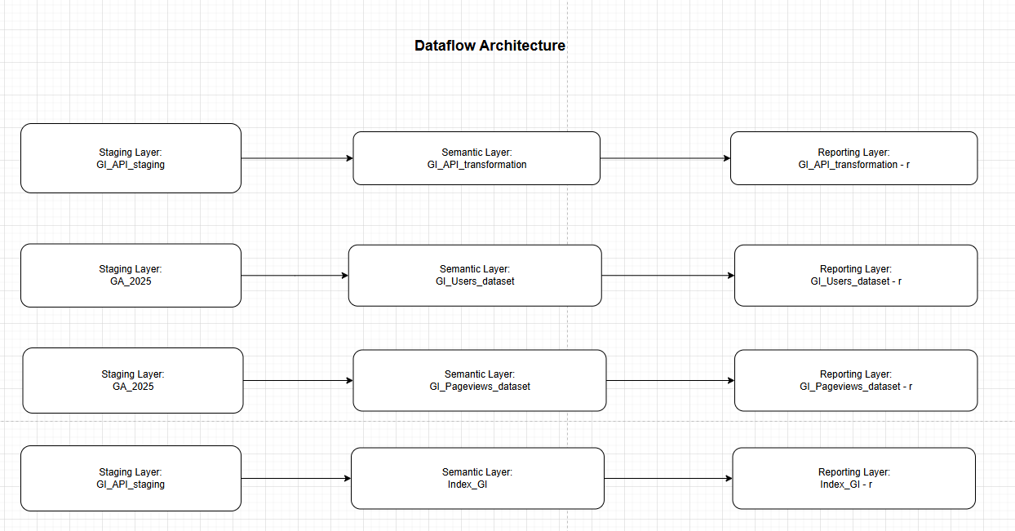

Summary
- GI_API_transformation - r table is joined with GI_Pageviews_dataset - r to meet further reporting needs.
- GI_API_transformation - r joined with GI_Users_dataset - r to meet further reporting needs.
- GI_API_transformation - r table is joined with Index_GI - r to meet further reporting hierarchical needs.
Core functionalities and Visual representation
The difference between Global Industries Report, Business Lines Report and Group Priorities Report is in offers type and categorization towards specific line. All functionalities for all three reports are the same.

Semantic model creation process
On blank report, I import tables from Datamart.
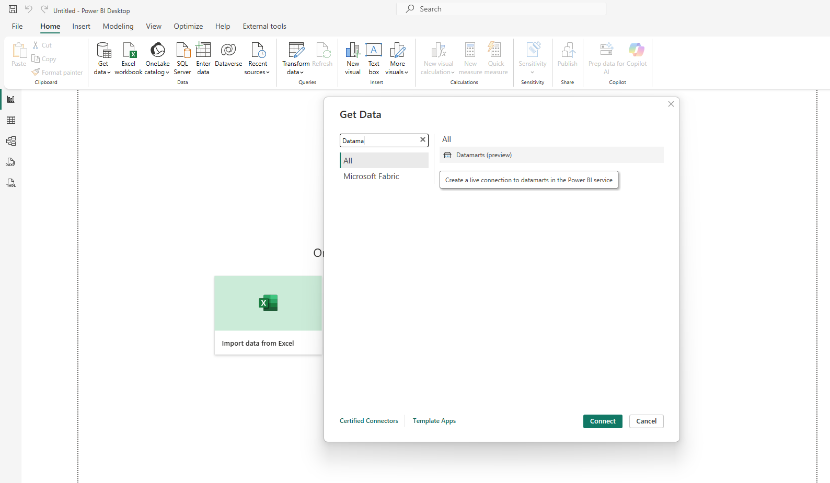
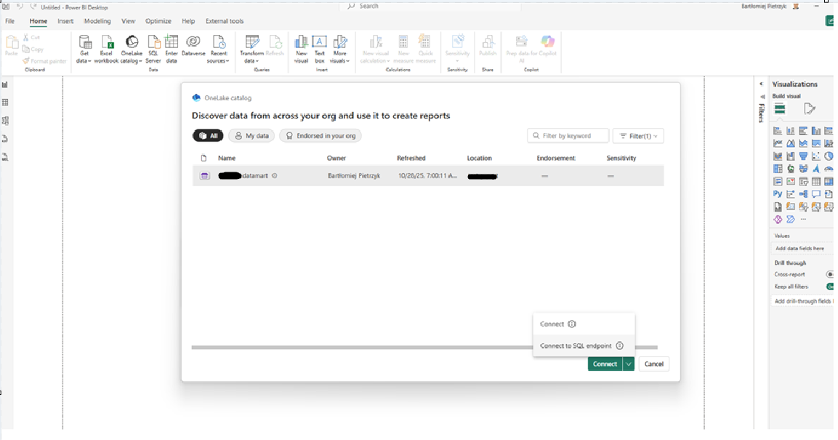

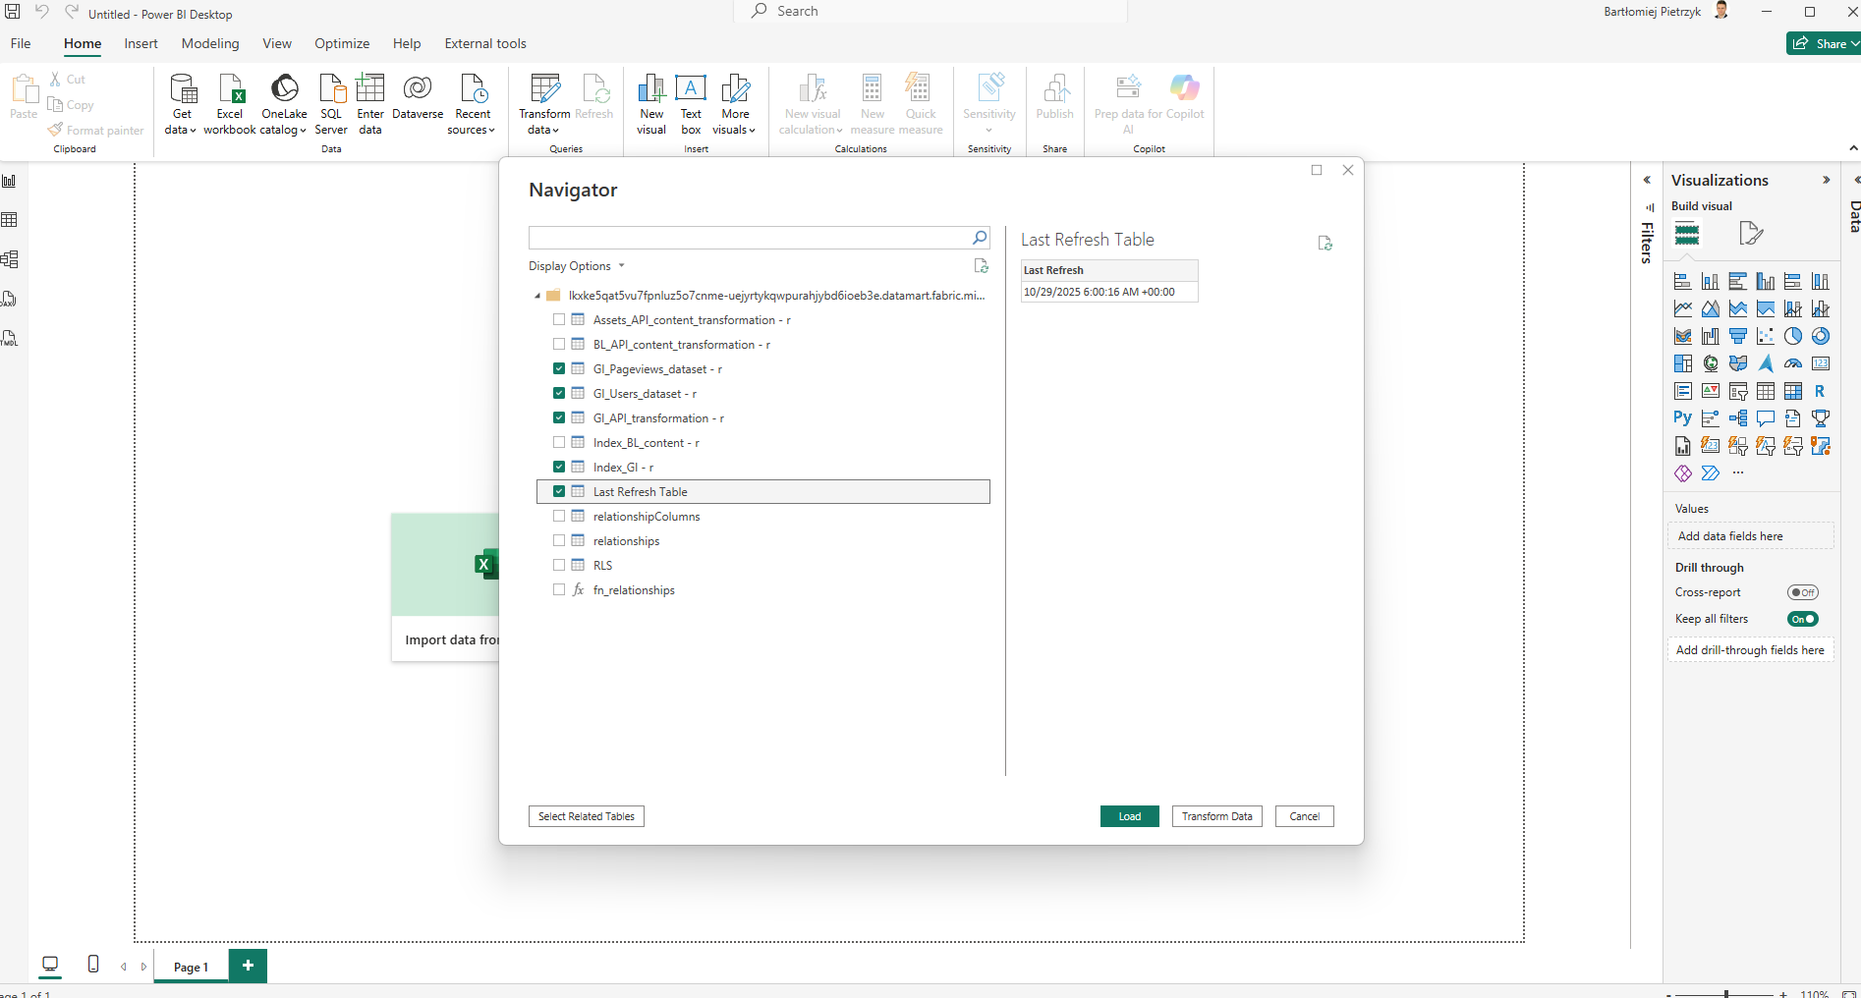
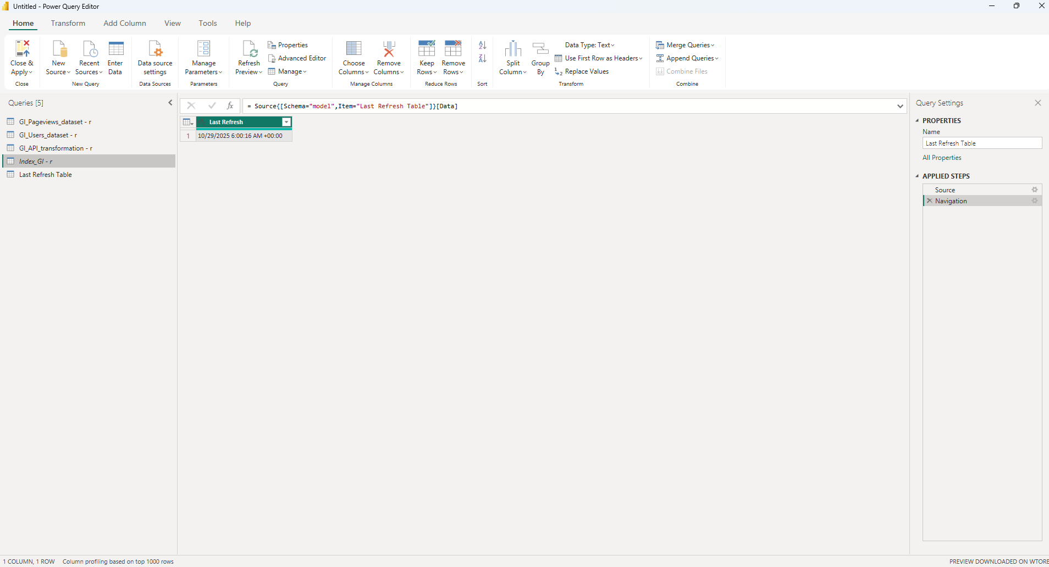
Transform data -> unable load for index -> close and apply -> add date tables
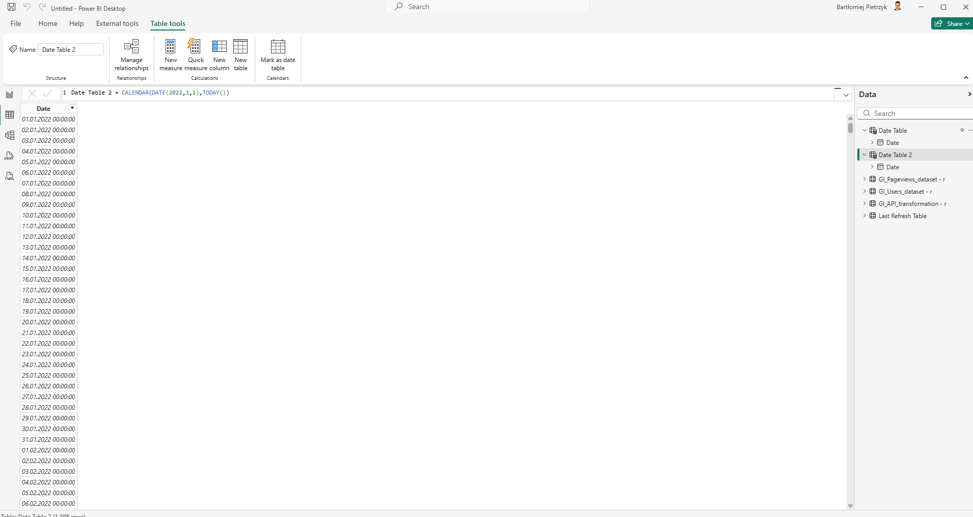
Go to manage relationships and assign accordingly
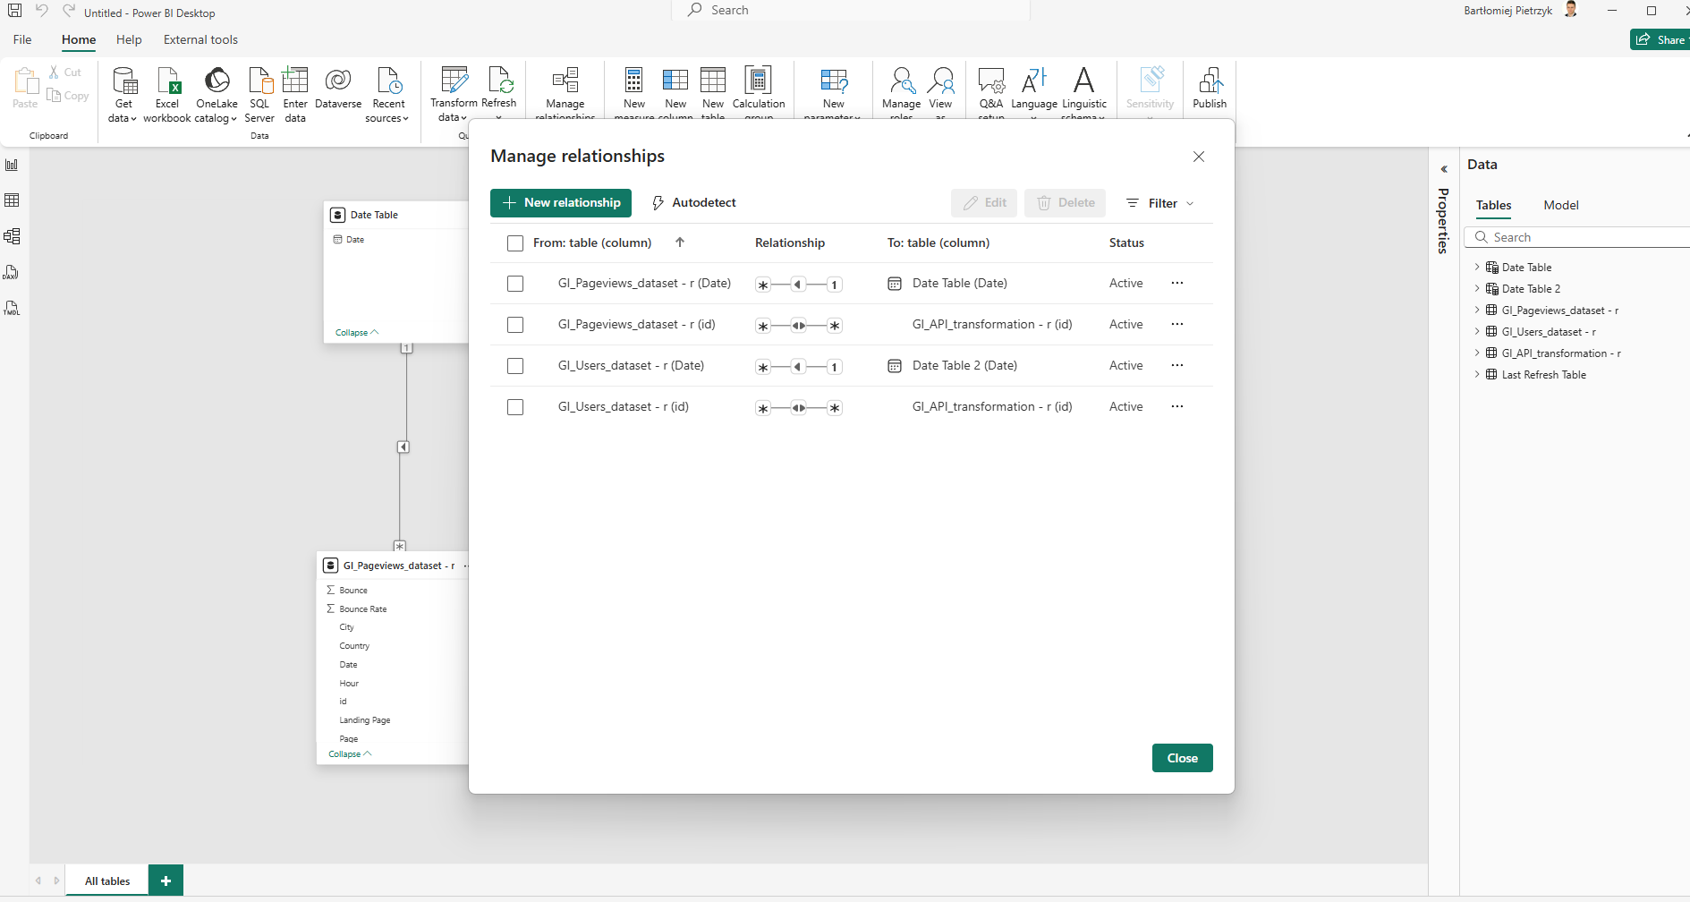
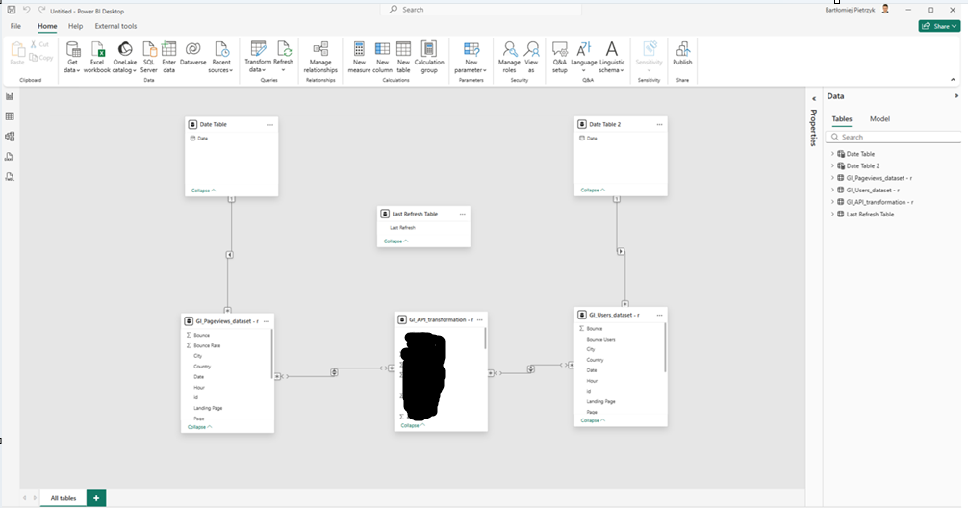
Publish the report to Power BI Service (same process as for BL content report).

